Modeling the Success of Citizen-Led Resistance Campaigns

  - Ethan Shiu
  - DATS 4001: Data Capstone
  - Professor Sushovan Mahji
  - May 2, 2025

Abstract:
In a political era of increased executive aggrandizement and rises in authoritarianism, citizen participation and involvement in politics are critical. Citizen-led resistance movements are one outlet for citizens looking to make their voices known and utilize freedoms of assembly and expression as detailed in the Universal Declaration of Human Rights. A lot of preparation and planning go on in the background of these protest movements that one sees on the news. This capstone seeks to investigate the many nuanced and complex facets of political resistance movements and explore the question: What makes a successful movement that can achieve its goals and influence socio-political change? Using the NAVCO 2.1 dataset to conduct exploratory data analysis, train a random forest model, conduct feature importance analysis, and create a user interface, this capstone revealed that the main categories of diversity, participation, defections, and repression are elements critical to movement success. It also showed that, while nonviolence as a primary methodology is important, the debate between violence and nonviolence is only one of many other, more important factors when it comes to movement success.

I. Introduction
In recent decades, the world has experienced a concentration of power in the hands of nations’ executives and an increase in authoritarianism and oppression. According to a Freedom House report released in February of 2025, the world has experienced its 19th consecutive year of decline in global freedom. In 2024, according to Freedom House, “60 countries experienced declines in their political rights and civil liberties, while only 34 registered improvements”, and authoritarian tactics in various sectors—including manipulation of elections, silencing of media, and targeting of legal professionals—have deepened in many countries. In this era of increasing authoritarianism, citizen-led political resistance movements are one critical tool for citizens seeking to hold governments accountable and restore governance in the service of the people. The field of nonviolent resistance is a rapidly growing field in political science focused on the study of citizen-led civil resistance movements, studying data on nonviolent campaigns and investigating theory and strategy. Their arguments point to different factors—nonviolent tactics, campaign structure, campaign goals, state repression, external actors, to name a few—that are most effective in making citizens ' voices known and effect socio-political change. This capstone project seeks to investigate this core question: What are the attributes of a successful citizen-led resistance campaign that can achieve its maximalist goal? Looking at a series of historical campaigns, this project will include exploratory data analysis findings, machine learning modeling, feature importance analysis, and will detail the creation of a user interface that allows users to interact with the data for themselves.

II. Data
As with many areas of study in political science, data for civil and non-civil citizen-led resistance campaigns is difficult to find in bulk. This is partially because there just have not been that many instances of resistance, and getting accurate and clean information on multiple datapoints for each campaign can be difficult.

Dataset
Despite this, though, the field of non-violent resistance has been working to collect more and more data regarding this subject. The main major data source used by a majority of non-violent resistance scholars is the Nonviolent and Violent Campaigns and Outcomes (NAVCO) Data Project. The data project is spearheaded by Erica Chenoweth, who is the Academic Dean for Faculty Development and Professor of the First Amendment with Harvard’s Kennedy School, director of the Nonviolent Action Lab, and a leading non-violent resistance political scientist. Alongside other political scientists, Chenoweth has produced three major datasets that catalogue nonviolent and violent resistance campaigns and their outcomes. This project utilizes the NAVCO 2.1 dataset, which compiles data on 384 mass movements that occurred between 1945 and 2013 in almost 150 different countries across the globe. The data is recorded by campaign by year and features over 74 different movement attribute variables that are qualitatively coded by researchers and experts on major armed and unarmed insurrections.

Resistance Movement Definition
To define a resistance movement, the NAVCO data project focuses on three main criteria when considering what incidents to include in their data project. They define a campaign as a “series of observable, continuous, purposive mass tactics or events in pursuit of a political objective”. The first criterion, observable, portrays the need for the campaign’s actions to be overt and documented. A campaign lacking significant available information on its organization, tactics, and goals would not be added. The second criterion is continuous. This criterion distinguishes mass movements from one-off protests or skirmishes. Mass movements must last anywhere from days to years and must be linked in a continuous effort. Actions considered tactics are extra-institutional and outside of normal political discourse. Lastly, the campaign must be purposeful. The movement must be focused on a central set of socio-political objectives as they conduct demonstrations to effect change. For campaigns in the NAVCO 2.1 dataset, the main maximalist goals campaigns are focused on are regime change, anti-occupation, and secession.

III. Data Wrangling

Missing Values
To prepare the data for exploratory data analysis and modeling, data wrangling involved multiple steps. First, to deal with missing values, I removed columns that had 20% of their values missing across the 385 rows. Then, with the remaining columns, I used Multiple Imputation by Chained Equations (MICE) with the MiceForests package to impute values for those that were missing. MICE is a technique used by data scientists to fill in missing values based on patterns in other features in the data. It uses predictive models to capture the patterns in the existing data and uses those relationships to impute missing values through an iterative process. MICE is best used when missing data is Missing At Random (MAR), meaning that the “probability of a variable being missing depends on other observed variables but not on the unobserved data”. In our case, the missing data largely reflects the inability of researchers or experts to find sufficient information to code a specific field. This lack of information can be influenced by numerous variables, many of which are recorded within the dataset (for example, year, state repression, media coverage), which means MICE has enough data to reference and work with in this instance.

Aggregation
After dealing with missing values, I aggregated the data to be focused on the campaign level, rather than campaign by year, as the multiple-year entries would skew the model’s view of success, as campaigns that would ultimately be successful often have years of actions, initiatives, and planning before achieving their goals. To do this, I used a mixture of mean, median, and mode functions to aggregate the features for each campaign, collapsing the data to include one unique campaign for each row.

Balanced Classes
Thirdly, I had to deal with balancing the data. Because historically, nonviolent and violent campaigns have a higher failure rate than success rate (which is the target variable I am trying to observe), this unbalance would make fitting the model particularly difficult. Overall, the data had 234 unsuccessful campaigns and 146 successful ones, but this distribution would also be skewed further when splitting the data with the train and test split. To balance the classes, I tried two methods. First, I tried using the class_weight = ‘balanced’ method with the SkLearn package. This allowed us to shift the way that the model weights each class (failure vs success), valuing the minority class higher and allowing the model to better capture the nuances of what determines the classification of the minority class. I also tried using the Synthetic Minority Over-sampling Technique (SMOTE) to deal with the class imbalance. Rather than change the weighting of the model, SMOTE creates synthetic samples of the minority class, giving the model more to work with. It does this by conducting a K-Nearest Neighbors clustering analysis on a row, and then a random nearest neighbor to choose two datapoints to base the synthetic datapoint on. It then calculates the distance between the points and creates a synthetic example at a random point in between by multiplying the difference by a random number between 0 and 1. It repeats this process multiple times to balance out the classes in the data.
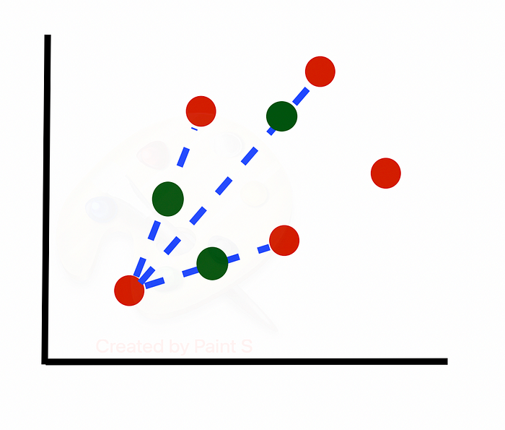
After testing out the models using both methods to deal with balancing classes, the SMOTE balancing ultimately led to better results across almost all metrics, and so that was the method I ultimately chose for the final model.

Feature Selection
Lastly, to narrow down the number of features used in the model, I created a preliminary random forest model intended to do a broad feature importance analysis to choose the top important features to include for the final model. To do this, I ran a Repeated Random Subsampling Validation (Monte Carlo cross-validation) with five sub-samples, split with 70% of values being within the train and 30% of values being within the test split. What that means is that I randomly split the data between the training and test splits five different ways, apportioning 70% of the values to the training and 30% to the test splits each time. Then I trained a preliminary random forest model on each of those five different splits and got the mean and standard deviation for each of the five SKLearn validation metrics: accuracy, precision, recall, F1-score, and ROC-AUC Score.
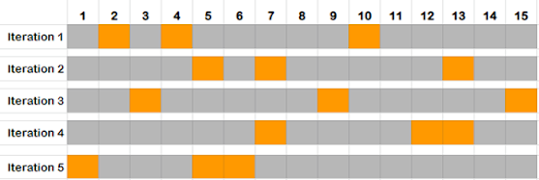
This allowed me to get a good idea of how well the model performed with different factors (for example, the inclusion of year) and informed the feature selection process to narrow down the features to the 20 most important ones to target. In the feature selection process, I also checked for things like collinearity (how much different features interact with others) and used the SHAP package (Shapely Additive exPlanations) to run a feature importance analysis to determine the 20 features that most influenced the model’s predictions for classification of success. SHAP does this by using SHAP values that use game theory methodologies to track different attributes of different features and determine which ones are critical within the model’s logic.

Features
After performing the feature selection process, I ended up with 20 features, which I used to train my final model on. The target variable the model is looking at is success. This variable is a binary coded variable that reflects whether the campaign ended up achieving its maximalist goal. The 20 features are listed below, grouped by general category, and include brief descriptions.
- Target Variable:
  - Success: Binary - did the campaign achieve its maximalist goal?
- Features
  - Movement Participation:
    - Log_rel_part: Participation relative to population
    - Total_part: Total participation
  - Diversity
    - Div_class: Diversity over class
    - Div_ethnicity: Diversity over ethnicity
  - Campaign Attributes:
    - Camp_goals: Campaign goals
    - Camp_structure: Consensus based or hierarchical
    - Camp_orgs: Number of new named organizations affiliated
    - Camp_duration: Duration in years
  - Media:
    - Media_outreach: Campaign invests in media coverage
    - Dom_media: Extent of domestic media coverage
  - Defections:
    - Sec_defect: Security forces defect
    - State_defect: State officials defect
    - Wdrwl_support: Former state supporters withdraw
  - State Response:
    - Camp_backlash: Effect of state repression
    - Indiscrim: State repression is indiscriminate
    - Fatalities_range: Estimated fatalities
  - External Actors:
    - Ab_internat: International backlash
    - Sdirect: Sanctions placed
    - Camp_support: Campaign has formal external support
  - Others:
    - Violent_flank: Violent flank exists

IV. Modeling

Random Forest
Once the data was wrangled, I moved on to the modeling step. Because the target variable was binary, I focused on two basic classifier models and evaluated them against each other. The first model I tried was a random forest model with SKLearn. This was the model I hypothesized would perform the best due to its ability to deal with non-linear relationships and collinearity. This was the model I used to perform the initial feature selection, so I had a good idea of how well it performed with the general data, at least. For this model, I used the 20 SHAP-selected features, the SMOTE balancing, and then used GridSearch CV to tune the model. With GridSearch CV, the ultimate test data is split off and reserved to the side, and then it runs K-Fold Cross-Validation to tune the parameters of the model. K-Fold Cross-Validation is another type of validation separate from the Repeated Random Test-Train Split Validation used earlier.
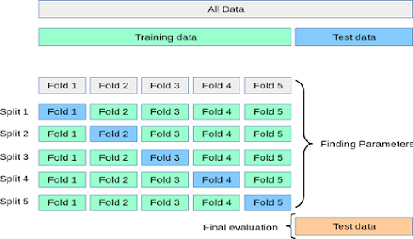
The K-fold cross-validation method splits the data into K groups or folds (in my case, five). Then it iterates over each group and creates a split where the target group is used as the validation and the rest of the groups are used as the training data. For our model, this meant that over the five iterations, each time 80% of the rows were used to train the model and 20% were used for validation testing. The validation data is different from the ultimate test data. GridSearch CV will use the results from the different splits of training and validation data to determine which parameters of the random forest model (number of estimators and maximum depth) are optimal, and then will use the test data that was reserved to the side to run the predictions after tuning.

Logistic Regression
The other model I tried was a logistic regression. Logistic regression generally performs more poorly when it comes to non-linear relationships and multicollinearity when compared to Random Forest, but I still wanted to see if it might perform better with the data. For the Logistic Regression model, I also used the SHAP selected features and SMOTE balancing. I initially tried using GridSearch CV for this model as well, but it ended up overfitting a little bit and would skew one metric to perform very high but leave the others low. So, I opted not to use it for the logistic regression model.

Results
These were the results of both models side by side across the five target metrics. 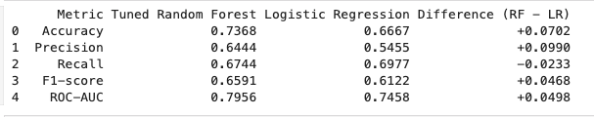
On the metric side, I was looking more closely at the recall score due to the nature of my user interface, which will be discussed later. Recall is calculated by dividing the number of true positives the model predicts by the sum of the number of true positives and false negatives.
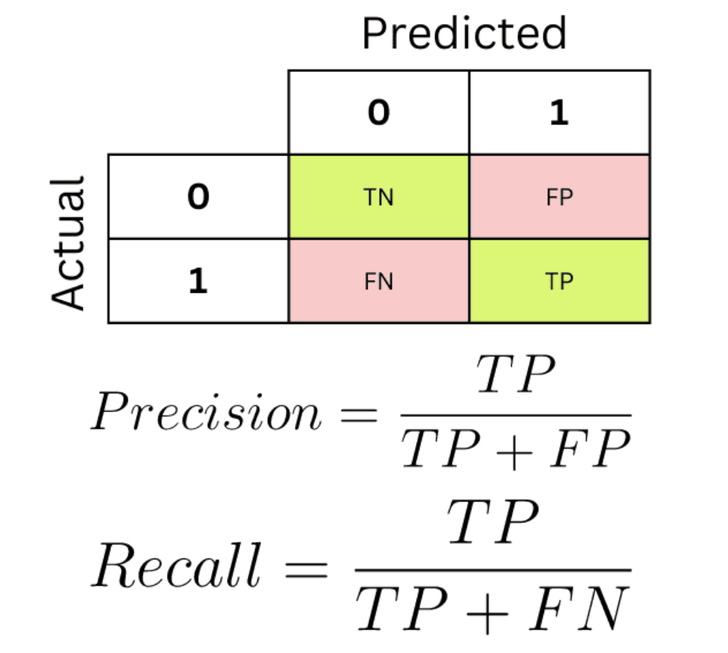
The recall metric would reveal the model’s ability to predict successful campaigns when given data for a prediction. Because I wanted to have a prediction feature in my UI that allows users to input theoretical data and determine how likely their theoretical campaign would be to succeed, this metric would be critical in evaluating my model’s performance. As it turned out, though, the models performed extremely closely, and the differences between the metrics were minimal. However, logistic regression did technically slightly outperform Random Forest in recall.
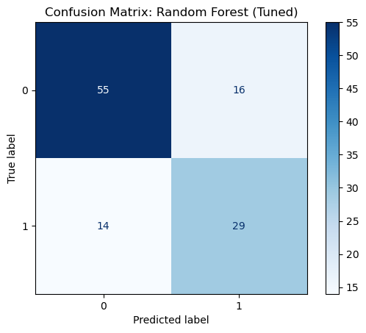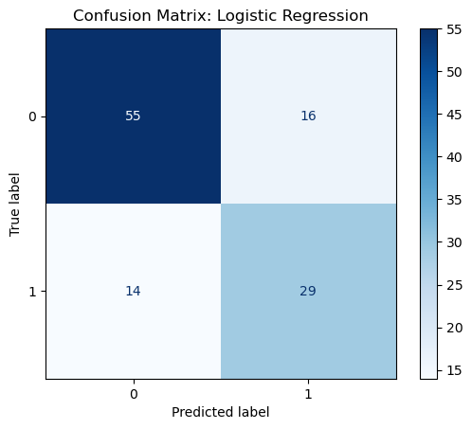
Additionally, the confusion matrices with the test data were identical. This was likely due to the relatively small dataset, and so the models captured similar trends and would generally predict in the same ways as they captured patterns.
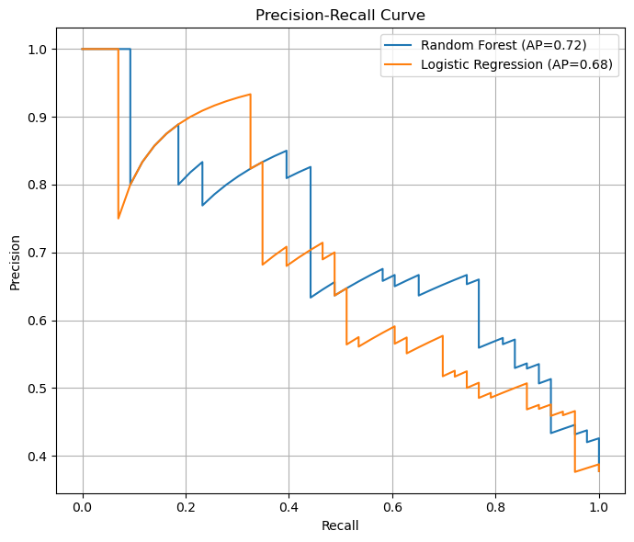
Looking at the precision-recall curve, both models struggled to balance precision and recall well, but the random forest model did slightly better than the logistic regression at maintaining the balance between correctly identifying and correctly predicting successes.
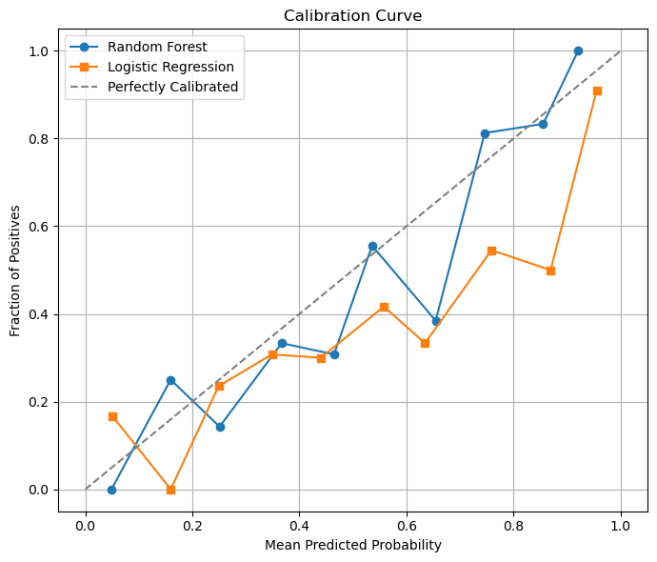
Then, with the calibration curve, which demonstrates how well the model’s predictions performed against actual outcomes, the random forest model also performed slightly better than the logistic regression.
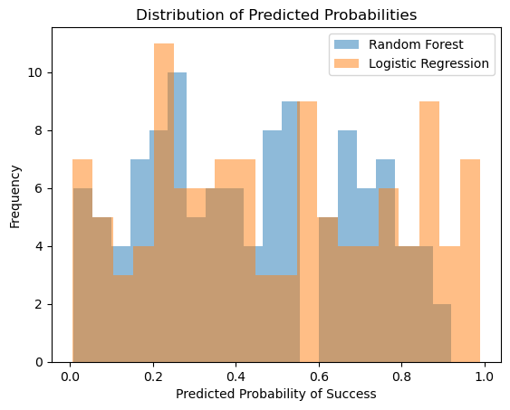
Lastly, looking at the distribution plot, which shows the distribution of probability of successes, shows that the random forest model is more conservative in its predictions when compared to the logistic regression, which was somewhat overconfident.
Given all of these factors, the models generally perform very similarly. Thus, it wouldn’t be too beneficial to ensemble or combine the models, so I decided to move forward with the random forest model. It performed slightly better in almost all metrics, except recall, which was very close to the logistic regression model. It performed better when balancing precision and recall, performed better when comparing predictions with actual outcomes, and was more conservative in its predictions.

V. Findings
Feature Importance Analysis 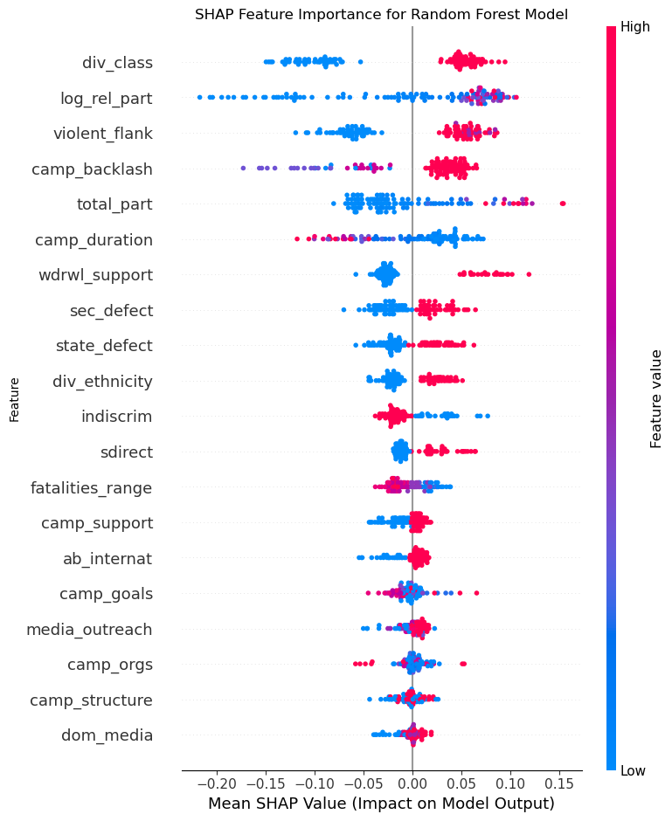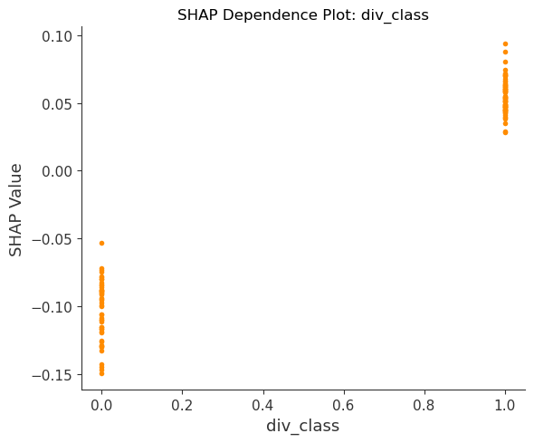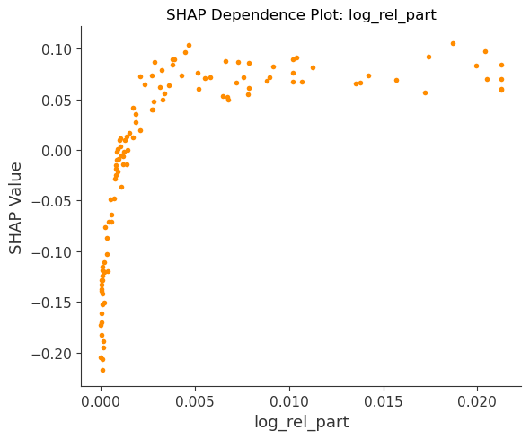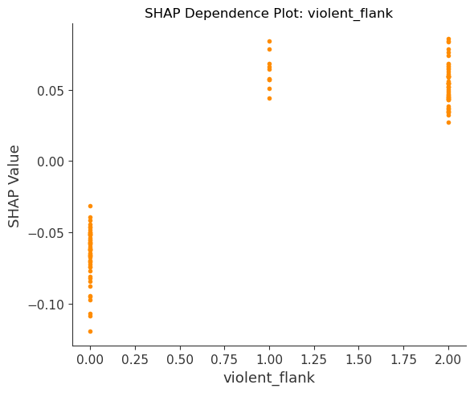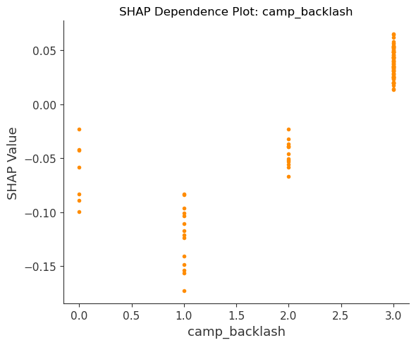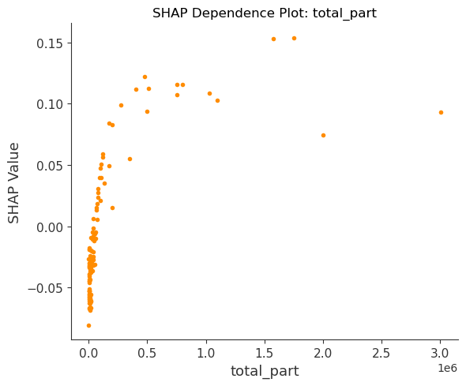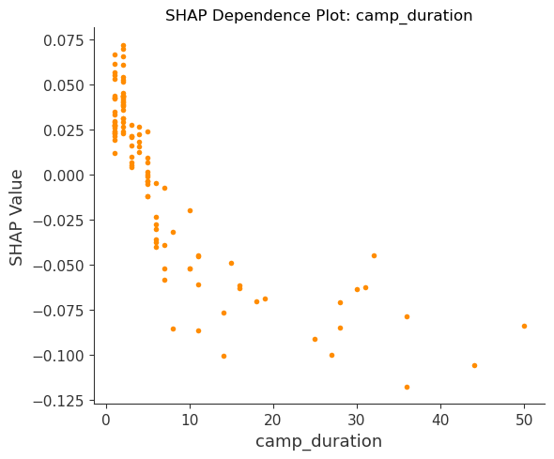

Using the tuned random forest model, I used the SHAP package to run another feature importance on just the 20 features used in the final model. The SHAP bee swarm summary plot lists the features in order of their importance based on the shape-ly values. SHAP uses its game theory methodology to observe how different factors influence the resulting predictions and returns shape-ly values that reflect these influences on a relative scale. The plots below are SHAP dependence plots, which expand on the relationships between feature values and shape-ly values for individual features. Looking at this feature analysis, the top five most important features that the model used to predict success are class diversity (higher diversity associated with success), participation relative to population (higher relative participation associated with success), the presence of a violent flank (absence of violent flank associated with success), the campaign’s response to backlash (increased mobilization post-backlash associated with success), and total movement participation (higher total participation associated with success.
Looking at the top 10 or 11 features, four general categories emerge as factors important to consider. Participation, as explained earlier in the top five important features, with higher total and relative participation numbers being associated with success. Diversity is also important, with ethnic diversity and class diversity being among the top 10 features, and higher diversity being associated with success. Defections with security forces defections, state officials’ defections, and the broad withdrawal of support by previous state supporters are all associated with success and within the top 10 important features. Lastly, repression with indiscriminate repression and increased mobilization in response to repression being associated with success and being within eh top 11 features. Thus, according to my model, these four categories are the factors that campaigns should most consider when planning for campaign success.

Primary Method
The other main finding from this capstone regards the efficacy of non-violence. According to many nonviolent resistance scholars, including Erica Chenoweth have asserted that nonviolent resistance is more effective when compared to violent resistance. According to their 2011 book written in collaboration with Maria Stephan, Chenoweth asserts that “campaigns of nonviolent resistance were more than twice as effective as their violent counterparts”. The analysis done by these scholars was derived from data in the initial NAVCO 1.3 dataset. My analysis of the NAVCO 2.1 dataset (which contains different campaigns and is formatted with different features and has data by year) supports this assertion. In the historical data, 27% of the violent campaigns succeeded while 55% of nonviolent campaigns achieved their goals. Additionally, my preliminary random forest model gave campaigns that were violent an average of 30% probability of success, while it gave nonviolent campaigns a 58% chance of success.
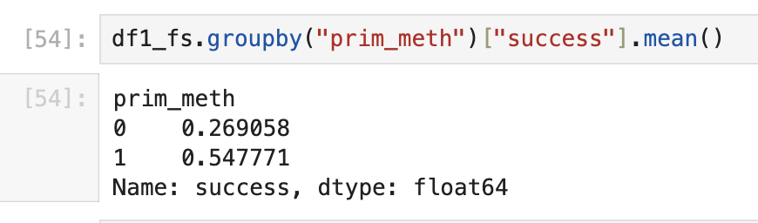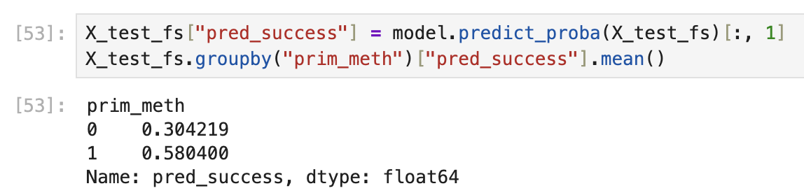
Interestingly, though, looking at the initial feature importance done to determine which features should be included in the final model, prim_meth, the variable that reflects whether the campaign was primarily violent or nonviolent, is the 2nd least important feature of the 27.
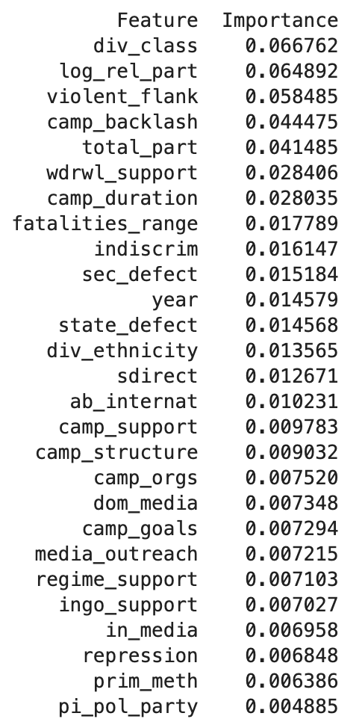
Overall, while this confirms that nonviolence is generally more effective than violence, my analysis of the NAVCO 2.1 dataset demonstrates that the primary method of resistance is by far the determining factor of the success of a movement. Though the primary method can indeed influence the outcomes of other attributes, there are many other factors of campaigns that more directly influence the likelihood of success of a resistance movement.

VI. User Interface
After doing this analysis, I wanted to create a user interface that would allow the user to interact with the data and explore findings for themselves. The idea for the UI was to have two main features.
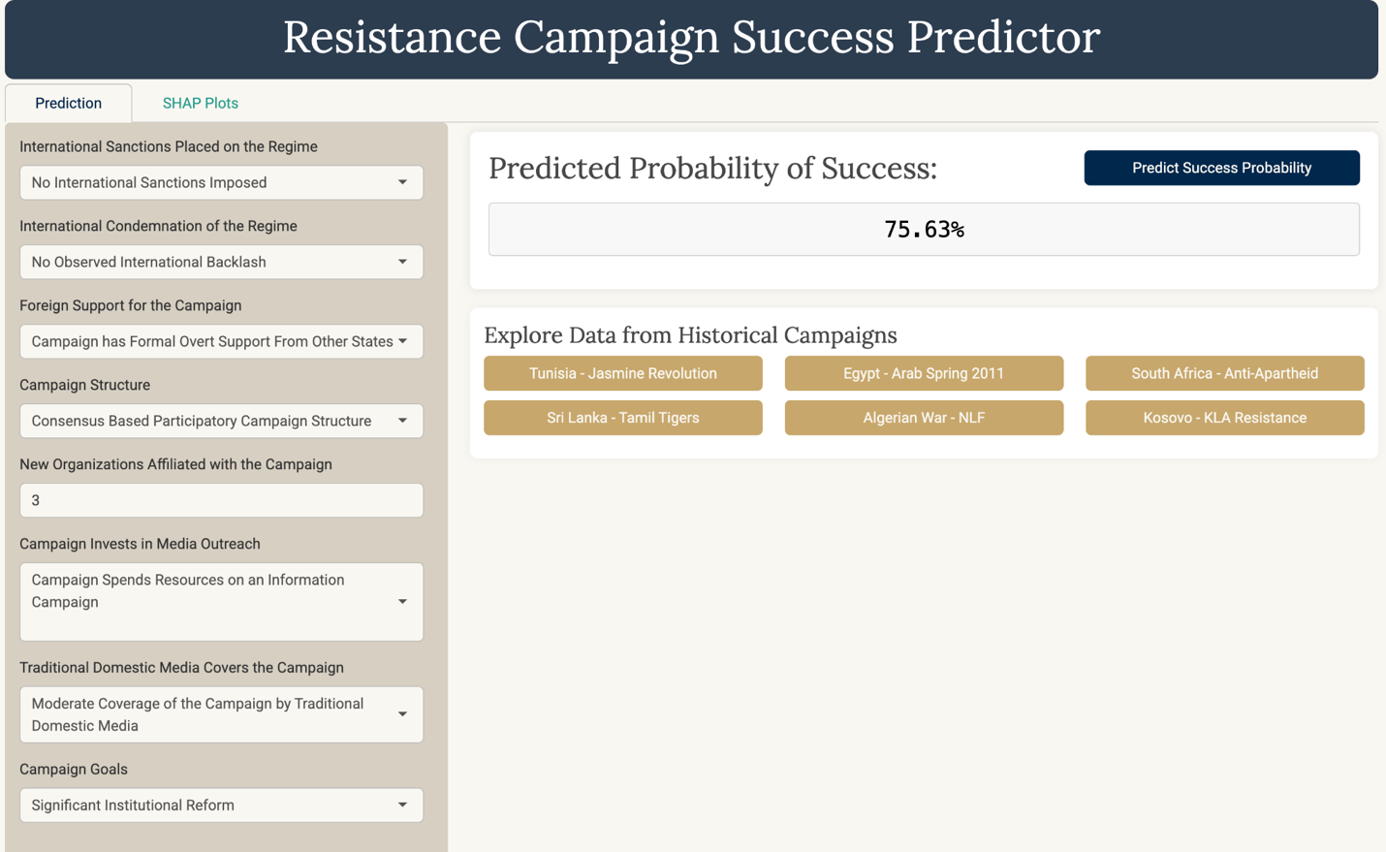
The first feature is a campaign success predictor. The idea is that there are dropdowns on the sidebar for each of the 20 features that are included in the final random forest model. With input values, the user can click the button to run the prediction (either at the bottom of the sidebar or on the main panel), and it will run my random forest model and return a probability of success score. Then the user can tweak their values to also explore how each factor influences the success score. Additionally, there are buttons on the bottom of the main panel that allow you to autofill values from relatively well-known campaigns from history into the dropdowns. This would allow the user to investigate historical campaigns and see what attributes could have been changed to improve or decrease the likelihood of success. The campaigns available are a general mix of campaigns that are violent, nonviolent, and transition from nonviolence to violence, and have mixed success outcomes.
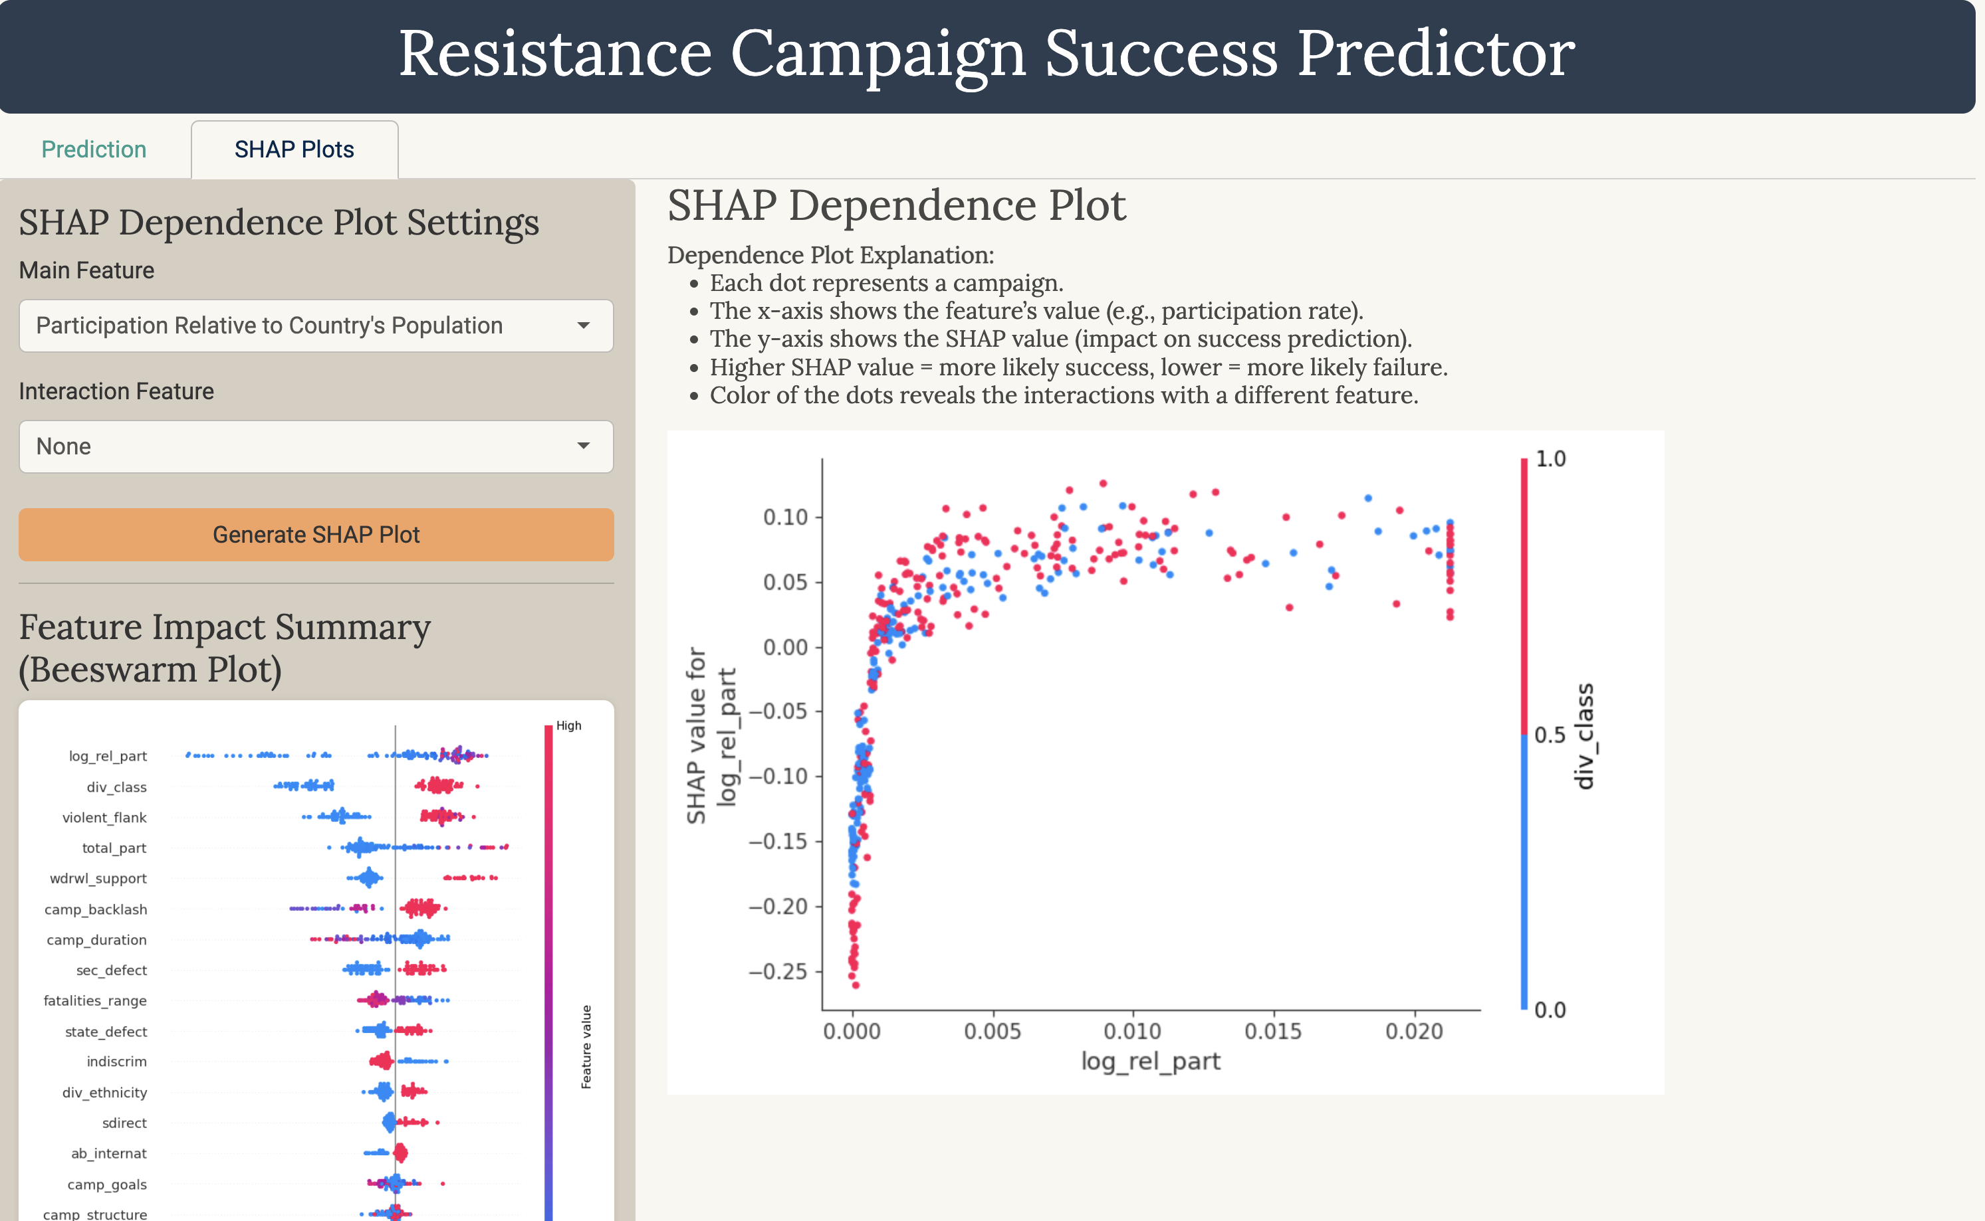
The second feature is a graphing functionality. I connected code that produces SHAP dependence plots to the dropdowns in the sidebar of the SHAP plots tab which allows the user to create a dependence plot for an individual feature of their choice, to see how different values for that variable influence the shape-ly values, and the user can choose an interaction feature which will be reflected in the color of the dots which allows them to see how other factors also are reflected in the dependence plot. Further, on the sidebar, there are two plots, a bee swarm plot and a bar plot, that demonstrate the feature importance if the user wants to reference it. The UI should be live and can be found here: https://y5dxcr-ethan-shiu.shinyapps.io/capstoneUI/.

VII. Conclusion
This capstone set out to explore the dynamics of violent and non-violent resistance campaigns and to investigate what contributes to a successful movement that can achieve its goals. Using the NAVCO 2.1 dataset, this capstone identified that campaign diversity, movement participation, state supporter defections, and the indiscriminate targeting of state repression (and the campaign’s response) are main aspects of resistance movements that are critical to success. It also demonstrated that while non-violence is more effective than violence when it comes to resistance methods, there are multiple other more important factors about a movement that determine its success. The capstone then created a user interface that would allow the user to explore these findings themselves. In the current environment of global politics, more and more emphasis will be placed on citizens to take a stand and hold the government accountable to its mandate from the people. Organized and coordinated resistance movements are crucial in ensuring there is a clear message from the people and affecting social and political change. A lot of preparation and strategic planning is behind the large protest movements and uprisings that one sees on the news. This capstone joins literature in the field of non-violent resistance to better fill out the understanding of the theory and strategy that leads to successful campaigns.

VIII. Bibliography
Awan, Abid Ali. “An Introduction to SHAP Values and Machine Learning Interpretability.” Accessed May 1, 2025. https://www.datacamp.com/tutorial/introduction-to-shap-values-machine-learning-interpretability.
Chenoweth, Erica. “NAVCO Data Project Version History and Description Guide.” Harvard Dataverse, November 6, 2019. https://doi.org/10.7910/DVN/CQFXXM.
———. “Why Civil Resistance Works.” Erica Chenoweth (blog), July 12, 2011. https://www.ericachenoweth.com/research/wcrw.
Chenoweth, Erica, and Christopher Wiley Shay. “List of Campaigns in NAVCO 1.3.” Harvard Dataverse, March 17, 2020. https://doi.org/10.7910/DVN/ON9XND.
———. “NAVCO 2.1 Dataset.” Harvard Dataverse, December 18, 2019. https://doi.org/10.7910/DVN/MHOXDV.
Freedom House. “NEW REPORT: Amid Unprecedented Wave of Elections, Political Violence and Armed Conflict Fueled 19th Consecutive Year of Decline in Global Freedom | Freedom House,” February 26, 2025. https://freedomhouse.org/article/new-report-amid-unprecedented-wave-elections-political-violence-and-armed-conflict-fueled.
Gorokhovskaia, Yana, and Cathryn Grothe. “The Uphill Battle to Safeguard Rights.” Freedom House, February 2025. https://freedomhouse.org/report/freedom-world/2025/uphill-battle-to-safeguard-rights.
Gupta, Vishesh. “Unveiling the Magic of MICE: (Multiple Imputation with Chained Equations).” Medium (blog), August 28, 2023. https://medium.com/@guptavishesh264/unveiling-the-magic-of-mice-multiple-imputation-with-chained-equations-37f4727da250.
Harvard Kennedy School. “Erica Chenoweth,” April 18, 2025. https://www.hks.harvard.edu/faculty/erica-chenoweth.
ICNC. “What Is Civil Resistance?” ICNC. Accessed May 1, 2025. https://www.nonviolent-conflict.org/about/civil-resistance/.
J, Greg. “Using Class Weight to Compensate for Imbalanced Data.” Medium (blog), July 31, 2022. https://medium.com/@bubbapora_76246/using-class-weight-to-compensate-for-imbalanced-data-6eff370185d3.
Maklin, Cory. “Synthetic Minority Over-Sampling TEchnique (SMOTE).” Medium (blog), May 14, 2022. https://medium.com/@corymaklin/synthetic-minority-over-sampling-technique-smote-7d419696b88c.
SciKit Learn. “GridSearchCV.” scikit-learn. Accessed May 2, 2025. https://scikit-learn/stable/modules/generated/sklearn.model_selection.GridSearchCV.html.
Sharanappa, Sunil. “Types of Cross Validations.” Medium (blog), January 5, 2022. https://medium.com/@sunils0506/types-of-cross-validations-f1ad3a871f67.
Wei, Dagang. “Essential Math for Machine Learning: Confusion Matrix, Accuracy, Precision, Recall, F1-Score.” Medium (blog), February 11, 2024. https://medium.com/@weidagang/demystifying-precision-and-recall-in-machine-learning-6f756a4c54ac.

Freedom House, “NEW REPORT: Amid Unprecedented Wave of Elections, Political Violence and Armed Conflict Fueled 19th Consecutive Year of Decline in Global Freedom | Freedom House,” February 26, 2025, https://freedomhouse.org/article/new-report-amid-unprecedented-wave-elections-political-violence-and-armed-conflict-fueled. ; Yana Gorokhovskaia and Cathryn Grothe, “The Uphill Battle to Safeguard Rights,” Freedom House, February 2025, https://freedomhouse.org/report/freedom-world/2025/uphill-battle-to-safeguard-rights.
ICNC, “What Is Civil Resistance?,” ICNC, accessed May 1, 2025, https://www.nonviolent-conflict.org/about/civil-resistance/.
Harvard Kennedy School, “Erica Chenoweth,” April 18, 2025, https://www.hks.harvard.edu/faculty/erica-chenoweth.
Erica Chenoweth and Christopher Wiley Shay, “NAVCO 2.1 Dataset” (Harvard Dataverse, December 18, 2019), https://doi.org/10.7910/DVN/MHOXDV.
Erica Chenoweth and Christopher Wiley Shay, “List of Campaigns in NAVCO 1.3” (Harvard Dataverse, March 17, 2020), https://doi.org/10.7910/DVN/ON9XND.
Chenoweth and Shay, “NAVCO 2.1 Dataset.”
Ibid.
Vishesh Gupta, “Unveiling the Magic of MICE: (Multiple Imputation with Chained Equations),” Medium (blog), August 28, 2023, https://medium.com/@guptavishesh264/unveiling-the-magic-of-mice-multiple-imputation-with-chained-equations-37f4727da250.
Greg J, “Using Class Weight to Compensate for Imbalanced Data,” Medium (blog), July 31, 2022, https://medium.com/@bubbapora_76246/using-class-weight-to-compensate-for-imbalanced-data-6eff370185d3.
Cory Maklin, “Synthetic Minority Over-Sampling TEchnique (SMOTE),” Medium (blog), May 14, 2022, https://medium.com/@corymaklin/synthetic-minority-over-sampling-technique-smote-7d419696b88c.
Maklin, “Synthetic Minority Over-Sampling TEchnique (SMOTE).”
Sunil Sharanappa, “Types of Cross Validations,” Medium (blog), January 5, 2022, https://medium.com/@sunils0506/types-of-cross-validations-f1ad3a871f67.
Sharanappa, “Types of Cross Validations.”
Abid Ali Awan, “An Introduction to SHAP Values and Machine Learning Interpretability,” accessed May 1, 2025, https://www.datacamp.com/tutorial/introduction-to-shap-values-machine-learning-interpretability.
Ibid.
SciKit Learn, “GridSearchCV,” scikit-learn, accessed May 2, 2025, https://scikit-learn/stable/modules/generated/sklearn.model_selection.GridSearchCV.html. ; Ibid.
Dagang Wei, “Essential Math for Machine Learning: Confusion Matrix, Accuracy, Precision, Recall, F1-Score,” Medium (blog), February 11, 2024, https://medium.com/@weidagang/demystifying-precision-and-recall-in-machine-learning-6f756a4c54ac.
Erica Chenoweth, “Why Civil Resistance Works,” Erica Chenoweth (blog), July 12, 2011, https://www.ericachenoweth.com/research/wcrw.

